# **Python COPY File using shutil.copy(), shutil.copystat()**

You must have the simple copying through copy option in windows. As you know Python can do almost anything that you can think of, let's see how to copy a file using Python. This will help you if you need to write a script of copying data from one place to another in servers where you don’t have access to the user interface.

Let’s take a look at the code.

First we need to import required libraries.

|  |
| --- |
| import os import shutil from os import path |

Now let’s check if the file exists or not

|  |
| --- |
| import os import shutil from os import path  if path.exists("hello.txt"):  src = path.realpath("hello.txt");  print("Yes file exits") |

The output is shown below.

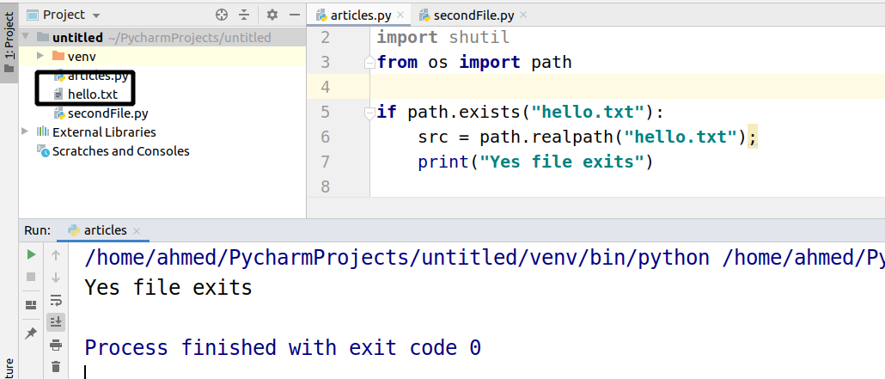

The following function is used to copy the file.

|  |
| --- |
| shutil.copy(src,dst) |

“src” stands for source location of the file and “dst” stands for destination.

Following command is used to Copy File with MetaData Information

|  |
| --- |
| shutil.copystat(src,dst) |

Let’s first use the simple copy.

|  |
| --- |
| import os import shutil from os import path  if path.exists("hello.txt"):  src = path.realpath("hello.txt");  print("Yes file exits")   dst = src + ".bakup"   shutil.copy(src, dst)  # shutil.copystat(src, dst) |

As you can see on the left side that the copy of the file is created.

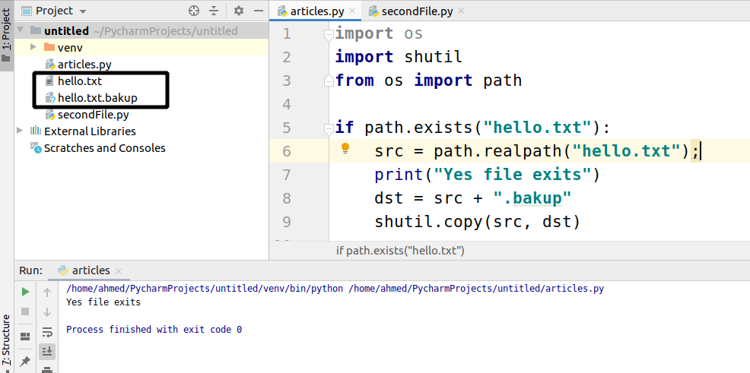

## Copy File with MetaData Information

MetaData information is **file permission, modification time** etc**.** The simple copy only copies the data in the file, not the MetaData information. Let’s now copy the metaData info too.

Here is the code.

|  |
| --- |
| import os import shutil from os import path  if path.exists("hello.txt"):  src = path.realpath("hello.txt");  print("Yes file exits")  dst = src + ".bakup"  shutil.copy(src, dst)  shutil.copystat(src, dst) |

